EX NO:15
DATE:
PARK VISITING TREND STACKED BAR CHART

AIM: To create a stacked bar chart in Tableau using the Park Visiting trend.csv dataset to visualize park visiting trends and display labels at the end of each bar for easy comparison.
Using “Park Visiting trend.csv” dataset, build a stacked bar chart and label it at the end of the bar.

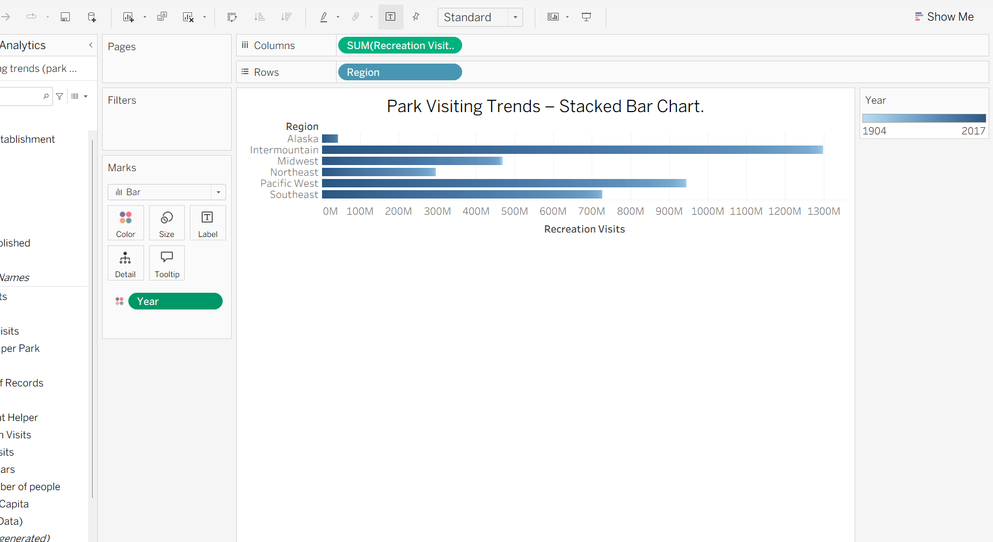

INTERPRETATION:
The stacked bar chart displays park visiting trends by comparing visitor counts across different categories or time periods. The stacked sections show the contribution of each category to the total number of visitors, while labels at the end of each bar make the values easier to read. This visualization helps identify visitor patterns and compare park visitation across the selected categories or periods.

